**Tom Rawlings**

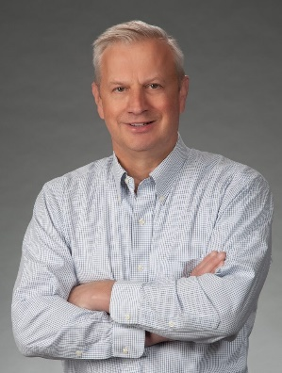

[**Click for Full CV**](https://protectingotherpeopleschildren.com/wp-content/uploads/2024/07/CV-THOMAS-CHARLES-RAWLINGS-December-2023.docx)

**Brief biography**

Tom Rawlings brings to this project his long career in juvenile justice, child protection, and capacity-building for ministries and organizations serving children in the US and around the world. For more than 30 years, Tom has served as an attorney, juvenile court judge, child rights ombudsman, and director of Georgia’s Division of Family and Children Services.

Tom holds a law degree from the University of Georgia, a Master’s degree in International Human Rights Law from Oxford University (UK), and a certification from the National Association of Counsel for Children as Child Welfare Law Specialist. In addition, Tom served as the Guatemela country director for International Justice Mission. He has trained child welfare, justice, and human rights professionals across the US as well as Guatemala, Lebanon, Peru, Armenia, Romania, and Thailand.

**Social Media**

Blog: <https://tomrawlings.substack.com/>

Book: <https://ProtectingOtherPeoplesChildren.com>

LinkedIn: <https://www.linkedin.com/in/tomcrawlings/>

Twitter: <https://x.com/tcrawlings>

**Recent media appearances and commentary**

Regular contributor to [CourtTV](https://x-default-stgec.uplynk.com/ause/slices/77f/5a41d9ac062d41bbb88c8ded2e0ef1c0/77f9d4cb6fb84d17898f6f32896e3e81/77f9d4cb6fb84d17898f6f32896e3e81_e.mp4) and [Atlanta news stations](https://www.11alive.com/article/news/special-reports/help-that-harms/alexander-family-georgia-child-abuse-investigation/85-9595cb35-8c0b-48a0-bcf4-44d90d0447d9)

Commentary for national outlets including [Washington Free Beacon](https://freebeacon.com/culture/clinically-insane/), [City Journal](https://www.city-journal.org/article/the-problem-with-california-ab-1955)

National commentary on [child welfare issues](https://www.fostercarecapacity.com/stories/op-ed-tom-rawlings-georgia-dfcs) and [child protection](https://www.devex.com/news/opinion-a-just-culture-will-help-aid-orgs-prevent-sex-abuse-scandals-106032).